AWS VPC Network Design Documentation
Objective
The objective of this project is to design and implement a scalable, production-ready AWS Virtual Private Cloud (VPC) that:
- Uses multiple subnet sizes based on workload demand
- Implements correct routing and controlled internet access
- Follows enterprise CIDR planning best practices
- Is secure, expandable, auditable, and suitable for long-term growth
This design is intended to be created once and scale for several years without redesign.
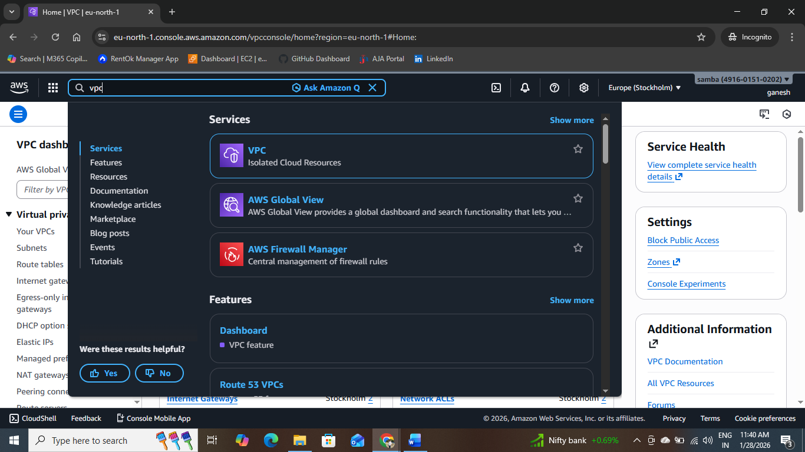

Task-1
CIDR & Capacity Planning (TASK 1)
Step-1
VPC CIDR Selection
- VPC CIDR: 10.0.0.0/16
- Total IP addresses: 65,536
Rationale
- /16 is an enterprise-grade baseline recommended by AWS
- Allows multiple large subnets with room for future growth
- Avoids early IP exhaustion
- Aligns with RFC1918 private addressing
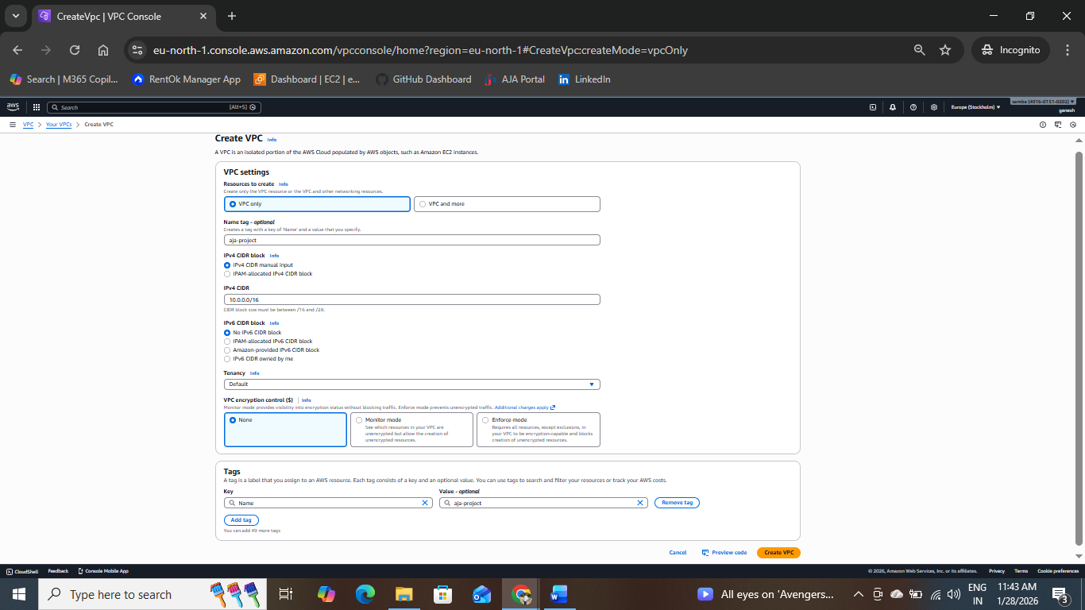

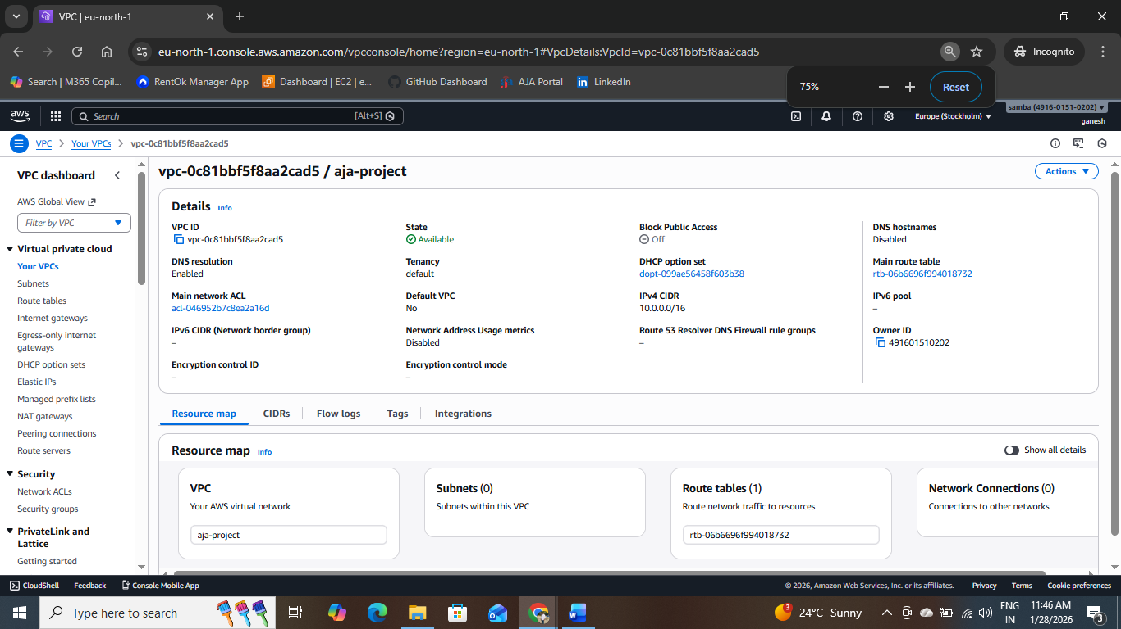

Task-2
Subnet Design – Unequal Sizes
Step-2
Design Rules Applied
- Largest subnets allocated first
- Proper CIDR boundary alignment
- No overlapping CIDR ranges
- All subnets fully contained within the VPC CIDR
Subnet Allocation Table
Subnet Name | Required IPs | CIDR | Usable IPs
Shared | ~8,192 | 10.0.0.0/19 | 8,192
Platform | ~4,096 | 10.0.32.0/20 | 4,096
App | ~2,048 | 10.0.48.0/21 | 2,048
Web | ~1,024 | 10.0.56.0/22 | 1,024
Edge | ~512 | 10.0.60.0/23 | 512
Admin | ~256 | 10.0.62.0/24 | 256
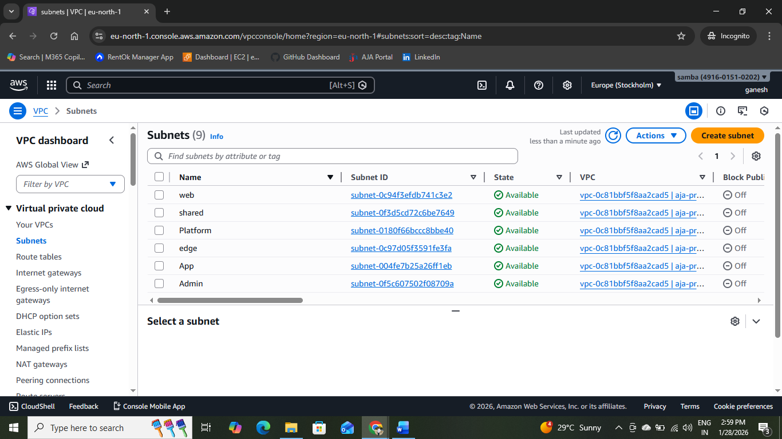

TASK-3
Internet Gateway Design
Step-3
IGW Configuration
- One Internet Gateway (IGW) created
- IGW attached directly to the VPC
Design Principle
Internet access is explicit, controlled, and limited only to required subnets.
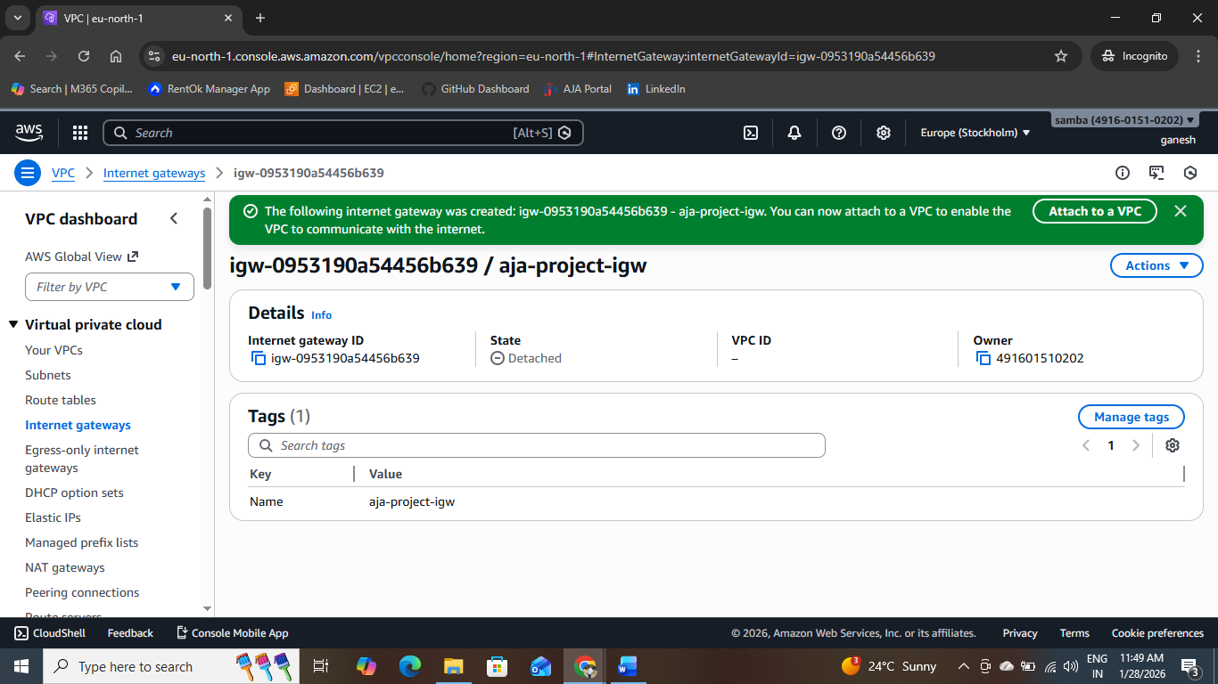

TASK 4
Route Table Architecture
Route Tables Created
Route Table | Used By Subnets | Routes
Public-RT | Admin, Edge | 10.0.0.0/16 → local0.0.0.0/0 → IGW
Private-RT | Web, App, Platform, Shared | 10.0.0.0/16 → local
Enterprise Rationale
- Clear separation of public and private traffic
- No implicit internet access for internal workloads
- Supports compliance and security audits
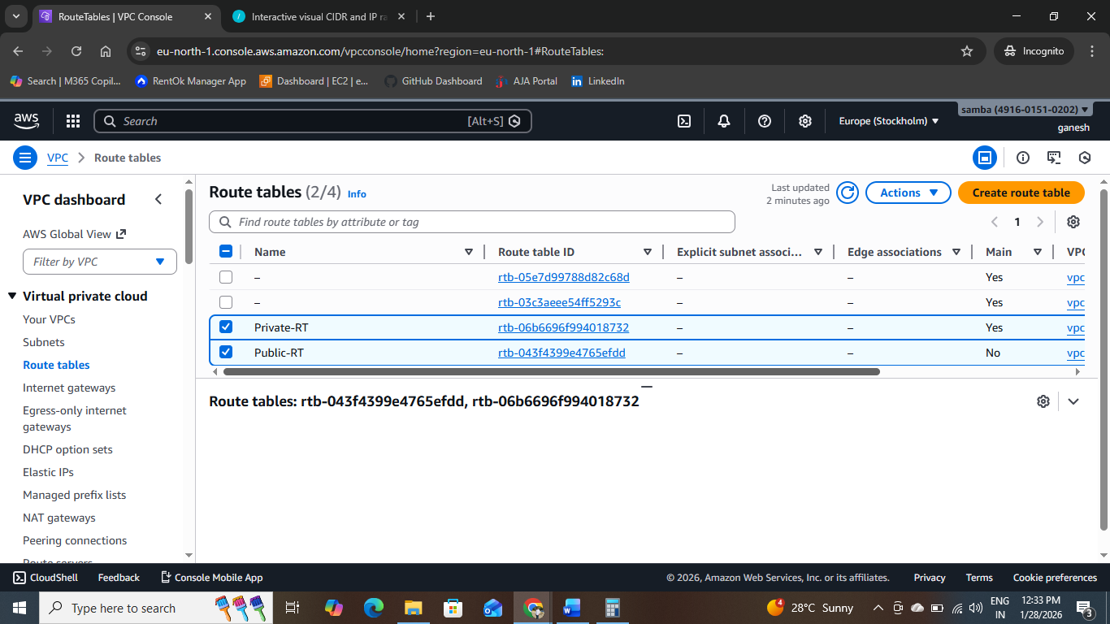

TASK-5
Route Table Association
Explicit Associations
- Admin Subnet , Edge Subnet → Public-RT
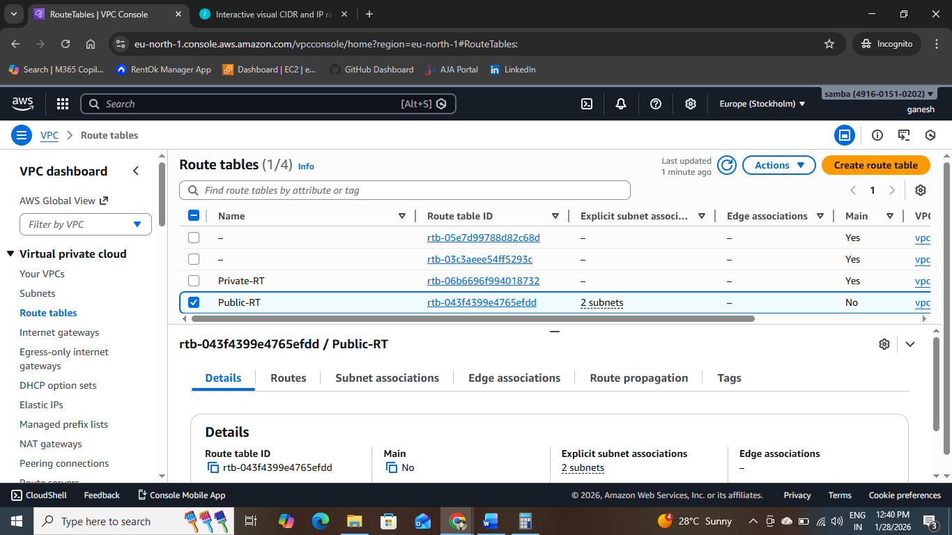

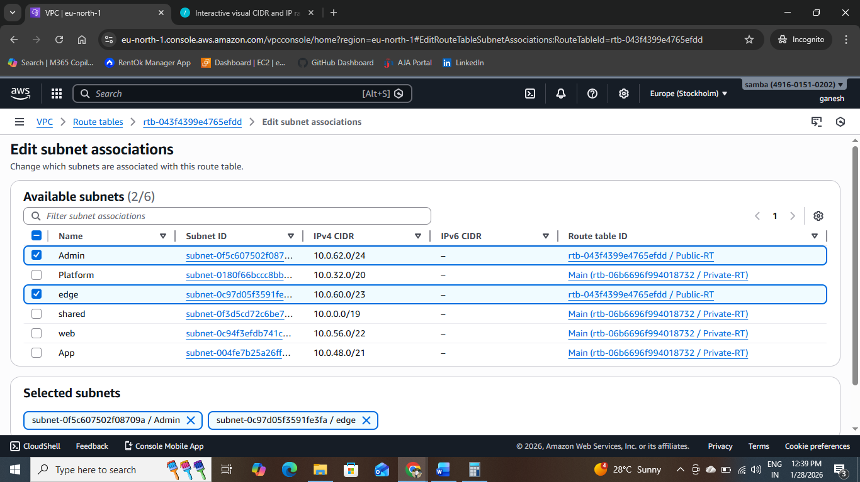
- Web, App, Platform, Shared → Private-RT
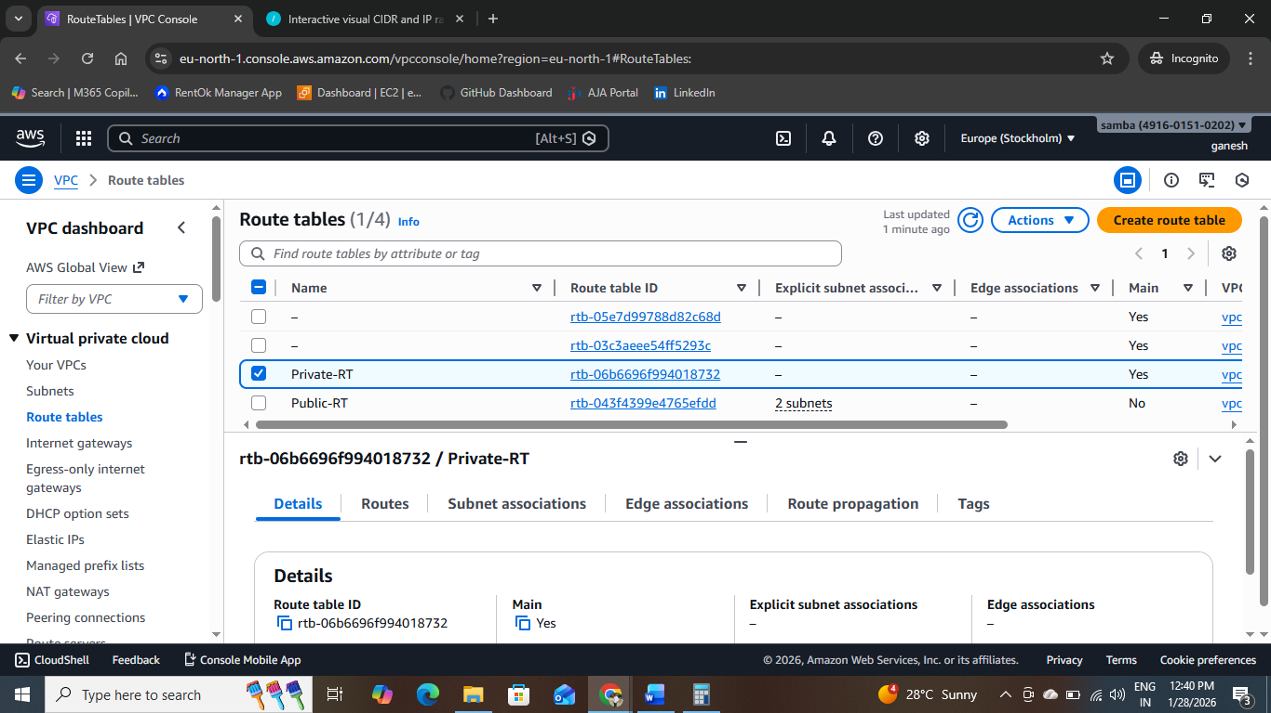
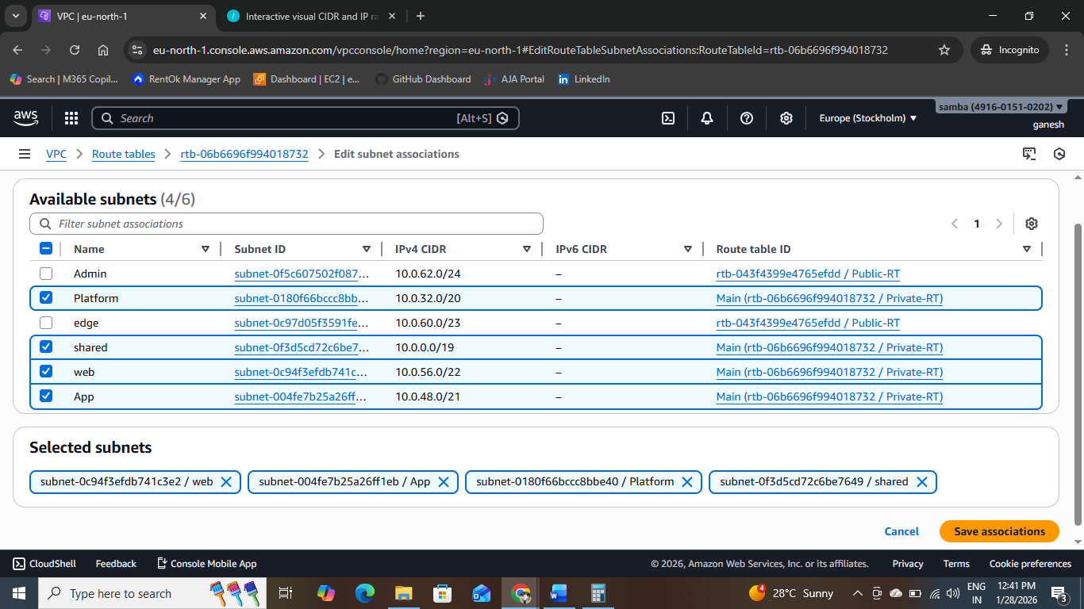

Route Table | Used By Subnets | Routes
Public-RT | Admin, Edge | 10.0.0.0/16 → local0.0.0.0/0 → IGW

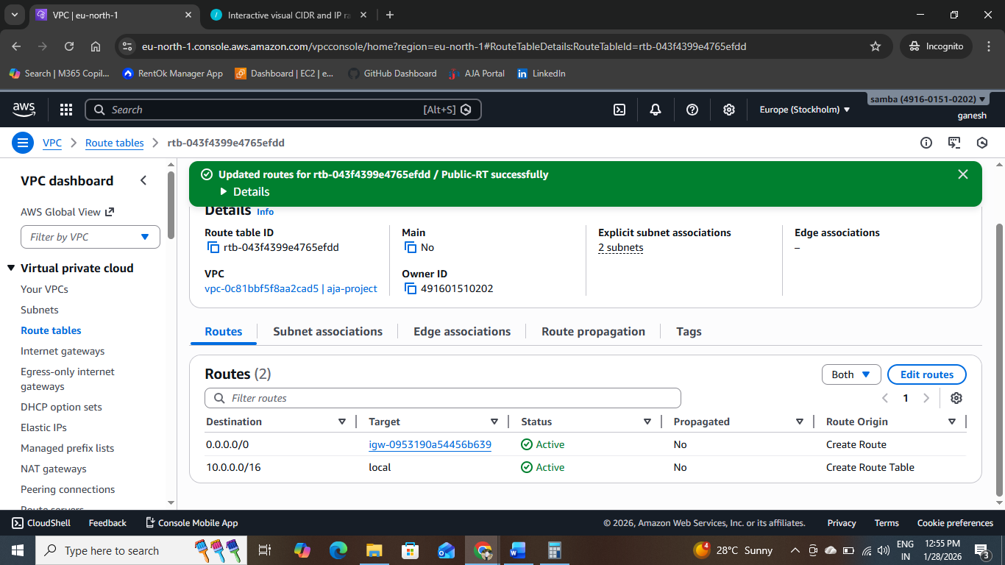

TASK - 7
Validation & Testing
Public Subnet Validation
- EC2 instances in Admin/Edge can:
  - Resolve DNS
  - Reach external IPs
  - Access the internet
Why: Route table contains 0.0.0.0/0 → IGW
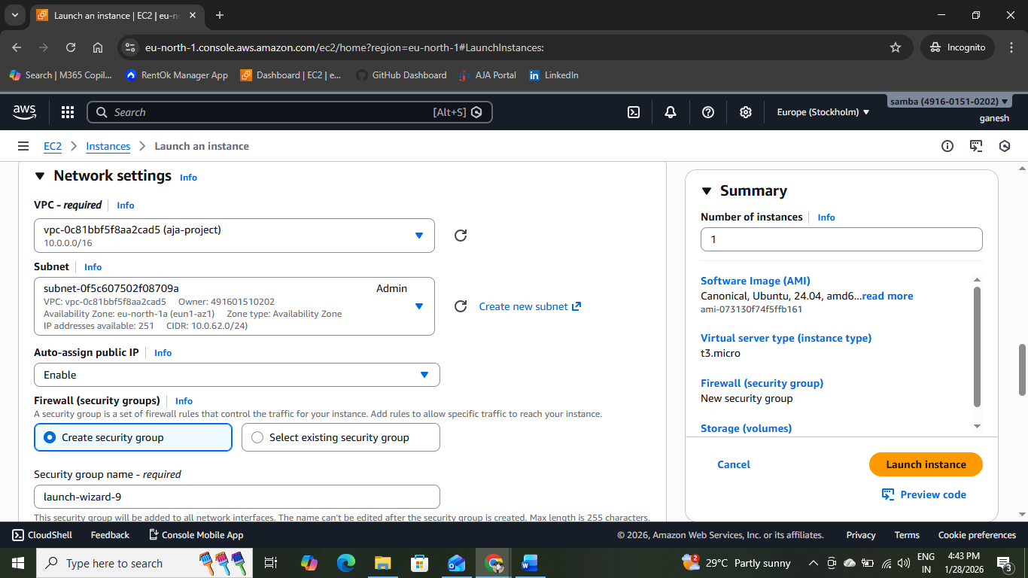

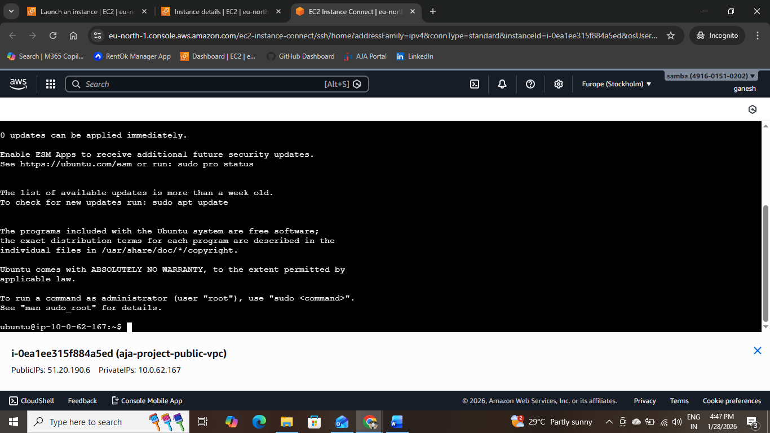

Private Subnet Validation
- EC2 instances in Web/App/Platform/Shared:
  - Cannot reach the internet
  - Can communicate internally
Why: No route to IGW exists
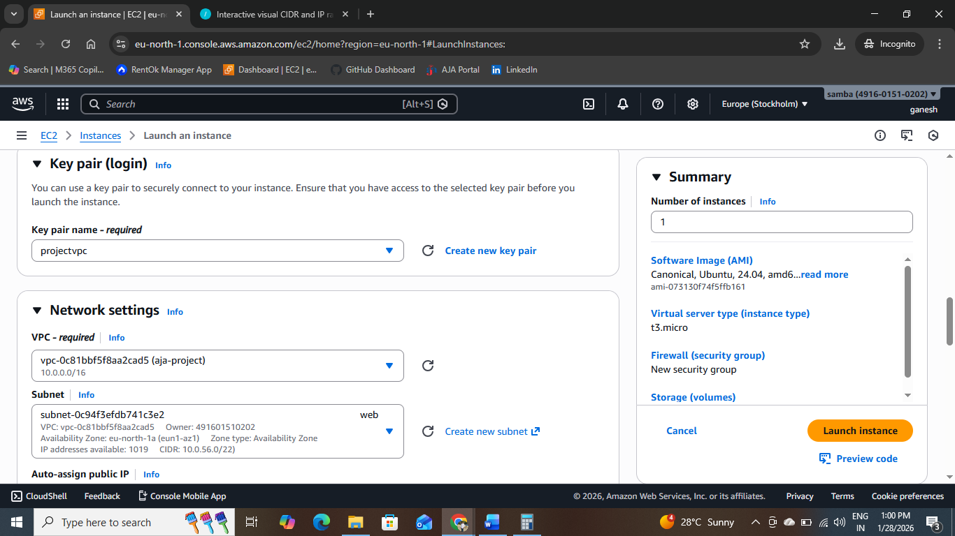
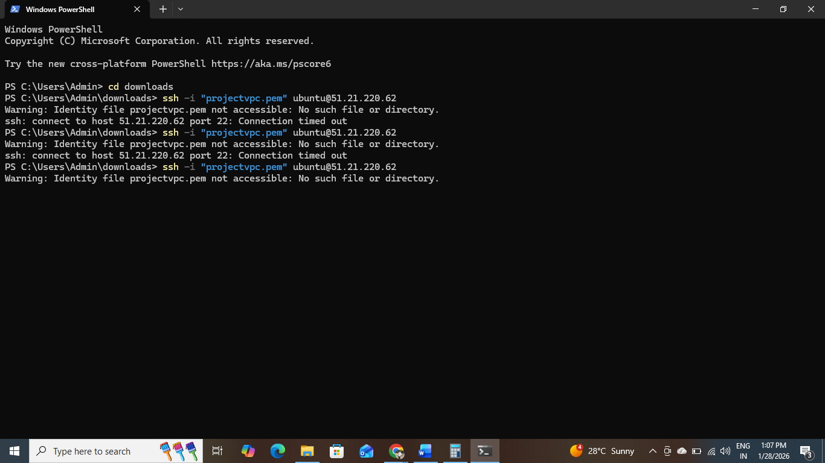
Internal Connectivity
- All subnets communicate via:
  - 10.0.0.0/16 → local route
TASK 8: Failure & Audit Scenarios
1. IGW Detached
- Public subnets immediately lose internet access
- Internal communication remains intact
- No data exposure occurs
2.Private Subnet Associated with Public-RT
- Private resources gain unintended internet access
- Violates security and compliance controls
- Considered a critical audit failure
3. Incorrect /19 Starting Address
- Breaks CIDR alignment rules
- Causes overlapping subnets
- AWS rejects subnet creation
- Results in unusable address space
4.Future Growth Support
- Large unused CIDR range reserved
- New subnets can be added without redesign
- NAT Gateways, Transit Gateways, or IPv6 can be introduced later

Deliverables
VPC & Subnet CIDR Table
Resource | Purpose | CIDR | IP Capacity
VPC | Enterprise Network | 10.0.0.0/16 | 65,536
Shared | Large Internal Services | 10.0.0.0/19 | 8,192
Platform | Containers / Tools | 10.0.32.0/20 | 4,096
App | Application Tier | 10.0.48.0/21 | 2,048
Web | Web Tier | 10.0.56.0/22 | 1,024
Edge | Ingress / Load Balancers | 10.0.60.0/23 | 512
Admin | Bastion / Operations | 10.0.62.0/24 | 256

2.Route Table Mapping
Route Table | Associated Subnets | Routes
Public-RT | Admin, Edge | 10.0.0.0/16 → local0.0.0.0/0 → IGW
Private-RT | Web, App, Platform, Shared | 10.0.0.0/16 → local

3.Architecture Diagram
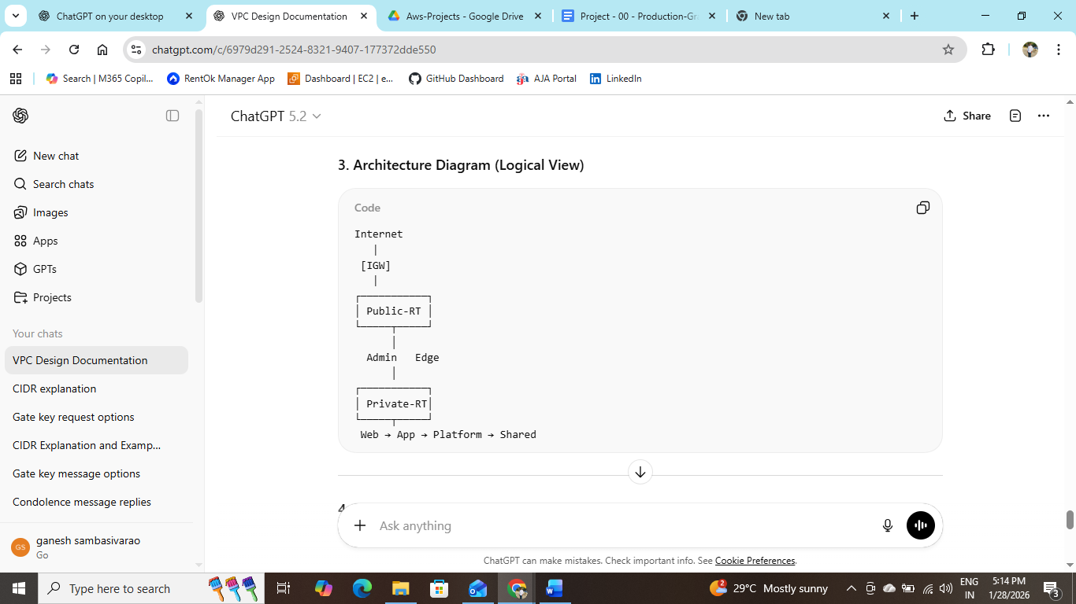
4.Traffic Flow Explanation
- Inbound Internet Traffic reaches only Admin and Edge subnets through the Internet Gateway.
- Outbound Internet Traffic is permitted only from public subnets via 0.0.0.0/0 → IGW.
- Private Subnets have no internet route and remain isolated.
- Inter-subnet Communication is enabled via the VPC local route (10.0.0.0/16).

5.Risk & Failure Analysis
Scenario | Impact
IGW detached | All internet access stops; internal traffic unaffected
Private subnet uses Public-RT | Unintended internet exposure (security breach)
Incorrect CIDR alignment | Subnet overlap or AWS rejection
IP exhaustion | Prevented by large VPC CIDR and reserved space

Conclusion
This AWS VPC design provides a secure, scalable, and production-ready network foundation built using enterprise CIDR planning and routing best practices. By clearly separating public and private subnets and controlling internet access through dedicated route tables, the architecture ensures strong security, predictable traffic flow, and auditability. The reserved address space supports future expansion without redesign, making this solution suitable for long-term, real-world enterprise cloud deployments.

